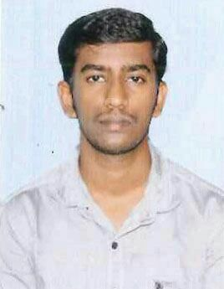

**ARUN R**

19/3,Elanthavilai,

Pallam post,

Kanyakumari District, Tamilnadu

Pin code: 629601

**Email Id** : [***iamarun.rs@gmail.com***](mailto:iamarun.rs@gmail.com)

**Contact No**. ***:* 8940242654**

**Objective:**

To work with an organization which provides me opportunity to improve my skills and knowledge in every aspect.

**Personal Qualities:**

* Hard work and dedicated to the work given to me.
* Ability to work as an individual as well as in group.
* Handling customers with good communication skills.
* Positive Thinker.

**Educational Qualification:**

|  |  |  |  |  |
| --- | --- | --- | --- | --- |
| Sl. No. | Degree | University Board | Percentage of Mark | Year of passing |
| 1 | B.E (Electronics and Communication Engineering) | Alpha College Of Engineering, Chennai-600124 | **60%** | 2016 |
| 2 | 12th (State Board) | Government higher secondary School, Vallankumaranvilai | **77%** | 2012 |
| 3 | 10th (State Board) | Government Higher Secondary School, Vallankumarnvilai | **90.2%** | 2010 |

**Technical Qualification:**

* Diploma in tourism and travel management (Aug-Oct 2017) at Riya institute of hospitality the travel expert.
* Amadeus ticket booking software.
* Basics in Galileo ticket booking software.
* Diploma in office automation (MS office).

**Co-curricular Activities:**

* Attended one month training at Riya the travel expert in Holidays section and ticketing section.
* Attended two days training in Amadeus training course at ResBird technologies p .Ltd.
* Knows about Itinerary preparation and fare calculation in Holidays section.
* Industrial visit in All India Radio, Chennai (August - 2014).

**Strengths:**

* Sincerity and Hardworking.
* Adaptable to any kind of situation in estranged group and helping tendency.

**Personal Profile:**

Name : Arun R

Sex : Male

Date of Birth : 31-12-1994

Languages known : Tamil and English

Religion : Hindu

Nationality : Indian

Hobbies : Playing cricket, Reading novels, bike riding

**Declaration:**

I hereby declare that all the above details provided by me are true to the best of my knowledge**.**

Place : Nagercoil Yours Sincerely,

R.Arun.